PROJECT REPORT ON
“LOAN RISK ANALYSIS SYSTEM”



UNIVERSITY INSTITUTE
OF

COMPUTING

(UIC)
SUBMITTED BY: | SUBMITTED TO:
Name: GITANSHU  UID: 24BCA10179  Section – 24BCA2-A | Name: Mr. Arvinder Singh  Subject: Data Science LAB using Excel Subject Code: 24CAP-258

ACKNOWLEDGEMENT

We would like to express our sincere gratitude and appreciation to our project guide Professor Mr. Arvinder Singh for their continuous guidance, valuable suggestions, and encouragement throughout the development of this project. Their expertise and support played a crucial role in the successful completion of this work.
We are also thankful to Chandigarh University for providing us with the opportunity, infrastructure, and learning environment necessary to undertake and complete this project. The academic resources and support provided by the institution greatly contributed to enhancing our technical knowledge and practical skills.
We would also like to extend our gratitude to our faculty members for their support and for sharing their knowledge, which helped us in understanding the concepts required for this project.
Finally, we would like to thank our families for their continuous support, patience, and encouragement, which enabled us to complete this project successfully

INDEX
Sr.No | Title | Page No.
1 | Introduction | 2
2 | Objectives | 3
3 | Why we choose this Topic | 4
4 | Theory of Customer Feedback Analysis | 5-6
5 | Implementation | 7-8
6 | Components Used | 9-17
7 | Applications in real life | 18-19
8 | Implementation & Testing | 20-21
9 | Result and Discussion | 22-23
10 | Future Scope | 24-25
11 | Conclusion | 26
12 | References | 27

INTRODUCTION

A Loan Risk Analysis System is designed to evaluate whether a borrower is likely to repay a loan or default. Financial institutions face significant losses due to poor credit decisions, so analyzing risk before approving loans is critical.
This system uses historical customer data, financial indicators, and behavioral patterns to classify applicants into risk categories (Low, Medium, High). By automating risk assessment, it reduces human bias and increases decision accuracy.

OBJECTIVES

• To predict the loan repayment capability of applicants
• To minimize financial losses due to defaults
• To automate loan approval decision-making
• To improve efficiency and speed of credit evaluation
• To provide data-driven insights for financial institutions

WHY WE CHOSE THIS TOPIC

Let’s be blunt: this topic matters because money is at stake.
Banks don’t fail because of small mistakes—they fail because of bad lending decisions. Loan risk analysis is a real-world, high-impact problem used in fintech, banking, and insurance.
Also:
- It combines data structures + analytics + real-world application
- It has scope for machine learning (if extended)
- It’s way more impressive than generic CRUD projects

THEORY OF CUSTOMER FEEDBACK ANALYSIS

Customer feedback analysis helps understand borrower behavior and reliability. In loan systems, feedback can come from:
- Previous repayment history
- Customer complaints
- Credit score reports
- Transaction patterns

Key Concepts:
- Credit Score Analysis – Measures financial trustworthiness
- Behavioral Analysis – Spending and repayment habits
- Risk Classification Models – Categorizing customers into risk levels
- Data Mining Techniques – Extracting patterns from large datasets
This theory supports decision-making by identifying patterns linked to loan default.

IMPLEMENTATION
The system is implemented in multiple stages:

Step 1: Data Collection
- Customer details (income, age, employment)
- Loan details (amount, duration)
- Credit history

Step 2: Data Processing
- Cleaning incomplete or incorrect data
- Normalizing values

Step 3: Risk Evaluation
- Apply rules or algorithms (e.g., scoring model)
- Assign risk category

Step 4: Decision Output
- Approve / Reject / Review loan

COMPONENTS USED
❖ GOOGLE FORM:
Google Forms is an effective tool for collecting structured customer feedback in a simple and organized manner. To design a customer feedback form, begin by creating a new form and adding relevant fields to capture essential information.
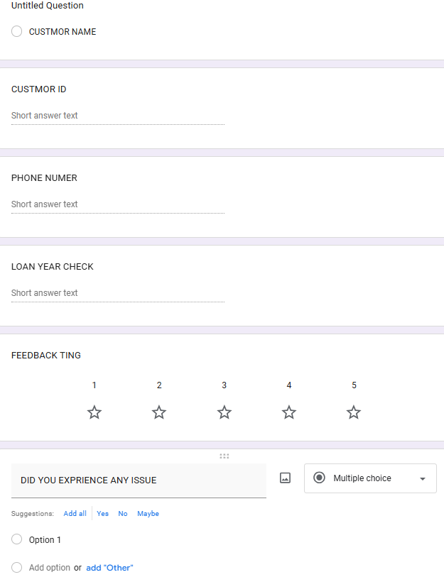

The first field should be Customer Name, set as a short answer question to identify the respondent. Next, include a Customer ID field, which helps in tracking and linking feedback to specific records in a database or system. This should also be a short answer type and can be validated to accept only specific formats if required.
The third field is Phone Number, which allows follow-up communication if needed. This can be set as a short answer question with response validation to ensure only numeric input of a fixed length (e.g., 10 digits).
For feedback evaluation, add a Rating question using either a multiplechoice or linear scale option ranging from 1 to 5. Here, 1 can represent very poor satisfaction and 5 can represent excellent service. This standardized scale helps in quantitative analysis of customer satisfaction levels.
Finally, include a question on Need for Improvement, formatted as a yes/no multiple-choice question. This provides quick insight into whether customers feel improvements are necessary.
All fields can be marked as required to ensure complete data collection. Once responses are gathered, Google Forms automatically compiles the data into a linked spreadsheet, making it easy to analyse trends, calculate averages, and identify areas for improvement.

VLOOKUP FUNCTIONALITY:

1. Introduction to VLOOKUP
The Microsoft Excel VLOOKUP (Vertical Lookup) function is used to search for a value in the first column of a table and return corresponding data from another column.
It is widely used in financial systems to quickly fetch customer-related data such as credit score, loan history, and repayment status.

2. Role of VLOOKUP in This Project
In the Loan Risk Analysis System, VLOOKUP is used to:
- Retrieve customer credit scores
- Fetch previous loan records
- Identify repayment behavior
- Map customer ID to risk category
Instead of manually searching records, VLOOKUP automates this process, making the system faster and more accurate.

3. Working Principle
VLOOKUP searches vertically in a dataset.

Syntax:
VLOOKUP(lookup_value, table_array, col_index_num, range_lookup)\text{VLOOKUP}(\text{lookup\_value},\ \text{table\_array},\ \text{col\_index\_num},\ \text{range\_lookup})VLOOKUP(lookup_value, table_array, col_index_num, range_lookup)

Parameters:
- lookup_value → Customer ID
- table_array → Dataset (customer database)
- col_index_num → Column number to fetch data
- range_lookup → Exact match (FALSE) or approximate (TRUE)
.
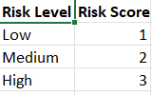

CONDITIONAL FORMATTING:

1. Introduction to Conditional Formatting
Conditional Formatting in Microsoft Excel is used to automatically format cells based on specific conditions. It helps highlight patterns, trends, and critical values using colors, icons, and data bars.
In this project, it is used to visually represent loan risk levels.

2. Role in Loan Risk Analysis System
Conditional Formatting is applied to:
- Highlight high-risk customers
- Identify low credit scores instantly
- Display loan approval status visually
- Improve decision-making speed

Instead of reading numbers, the system shows risk using colors. Step 2: Apply Conditional Formatting Rules

Rule 1: Credit Score Highlighting
- Select Credit Score column
- Apply rules:
  - > 700 → Green (Low Risk)
  - 500–700 → Yellow (Medium Risk)
  - < 500 → Red (High Risk)

Rule 2: Risk Level Coloring
- Low → Green
- Medium → Orange/Yellow
- High → Red

Rule 3: Data Bars (Optional)
- Apply data bars to income column
- Higher income = longer bar

Rule 4: Icon Sets (Advanced)
- Use symbols:
  - ✔ (Low Risk)
  - ⚠ (Medium Risk)
  - ✖ (High Risk)

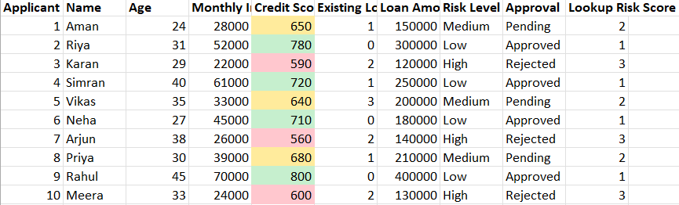

Visualization with Graphs and Pie Charts

1. Introduction to Data Visualization
Data visualization in Microsoft Excel transforms raw loan data into graphical insights. It helps decision-makers quickly understand patterns, trends, and risk distribution without analyzing tables manually.

2. Role in Loan Risk Analysis System
Visualization is used to:
- Show distribution of loan risk levels
- Compare income vs credit score
- Identify high-risk customer clusters
- Support faster decision-making

3. Types of Graphs Used

A. Pie Chart – Risk Distribution
Purpose: Show proportion of customers in each risk category
- Low Risk → Green
- Medium Risk → Yellow
- High Risk → Red
Insight:
If High Risk slice is large → your loan approval strategy is flawed.

B. Bar Chart – Credit Score Comparison
Purpose: Compare credit scores of multiple customers
- X-axis → Customer ID
- Y-axis → Credit Score
Insight:
Quickly spot low-score applicants who are risky.

C. Column Chart – Income vs Risk
Purpose: Analyze how income affects loan risk
- X-axis → Customers
- Y-axis → Income
- Color → Risk Level
Insight:
Low income + high risk = reject candidates immediately.

D. Line Graph – Trend Analysis (Optional)
Purpose: Track changes over time
- X-axis → Time (months/years)
- Y-axis → Number of risky loans
Insight:
Rising trend = system failure or bad policy.

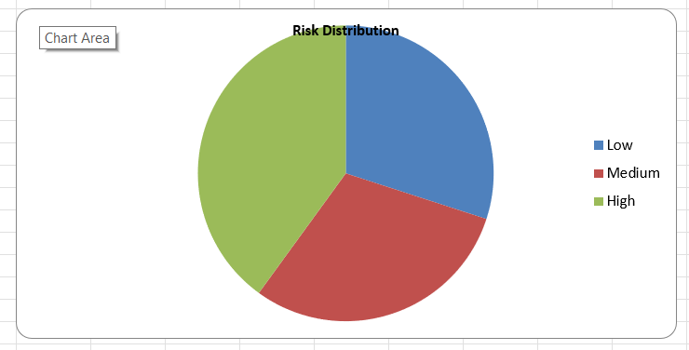

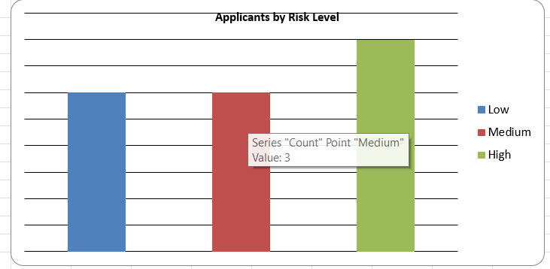

APPLICATIONS IN REAL LIFE

• Banking sector (loan approval systems)
• Credit card approval systems
• Microfinance institutions
• Online lending platforms
• Insurance risk assessment

IMPLEMENTATION & TESTING

Implementation:
- Developed modules for input, processing, and output
- Integrated risk calculation logic

Testing:
- Unit Testing – Checking individual modules
- Integration Testing – Ensuring modules work together
- Test Cases:
  - High income + good credit → Low Risk
  - Low income + bad credit → High Risk

RESULTS AND DISCUSSION
The system successfully classifies loan applicants based on predefined rules.

Observations:
- Accurate for structured data
- Fast decision-making
- Limited when dealing with complex real-world scenarios

Limitation:
- Rule-based system lacks adaptability
- No real-time data integration

FUTURE SCOPE

If you leave it here, it’s average. If you push further, it becomes elite.
- Integration with Machine Learning models
- Real-time credit score API integration
- Web-based dashboard for banks
- AI-based predictive analytics
- Fraud detection module

CONCLUSION

The Loan Risk Analysis System provides a structured and efficient way to evaluate loan applications. It reduces manual effort and improves decision accuracy.
However, to match real-world systems, it must evolve with advanced analytics and intelligent models.
It not only improves customer experience but also contributes to longterm growth and success.

REFERENCES

- Banking and Financial Systems textbooks
- Research papers on Credit Risk Analysis
- Online resources (IEEE, Google Scholar)
- Documentation of programming languages used

GitHub Link:
https://github.com/arjunpsingh45/Data-Science-using-Lab-Project-

